Safety: All proper safety equipment for the area.

Purpose: The purpose of this procedure is to perform a standardized drop test and ensure that drop test is performed properly.

Procedure:

- Each line at the Repackaging facility is equipped with a standard 1 meter bar to perform the drop test.
- When dropping a pouch employee shall hold top of pouch evenly with top of drop test bar.
- Employee will drop pouch vertically to the floor.
- Result of drop test will be documented as a P for Pass and F for Fail on weight sheets in the drop test block.
Passing = Pouch appears as it was before it was dropped.
Fail = Any part of the pouch has weakened seams or torn open

- Drop Test is to be performed every 15 minutes.
6. See picture below for demonstration of drop test.

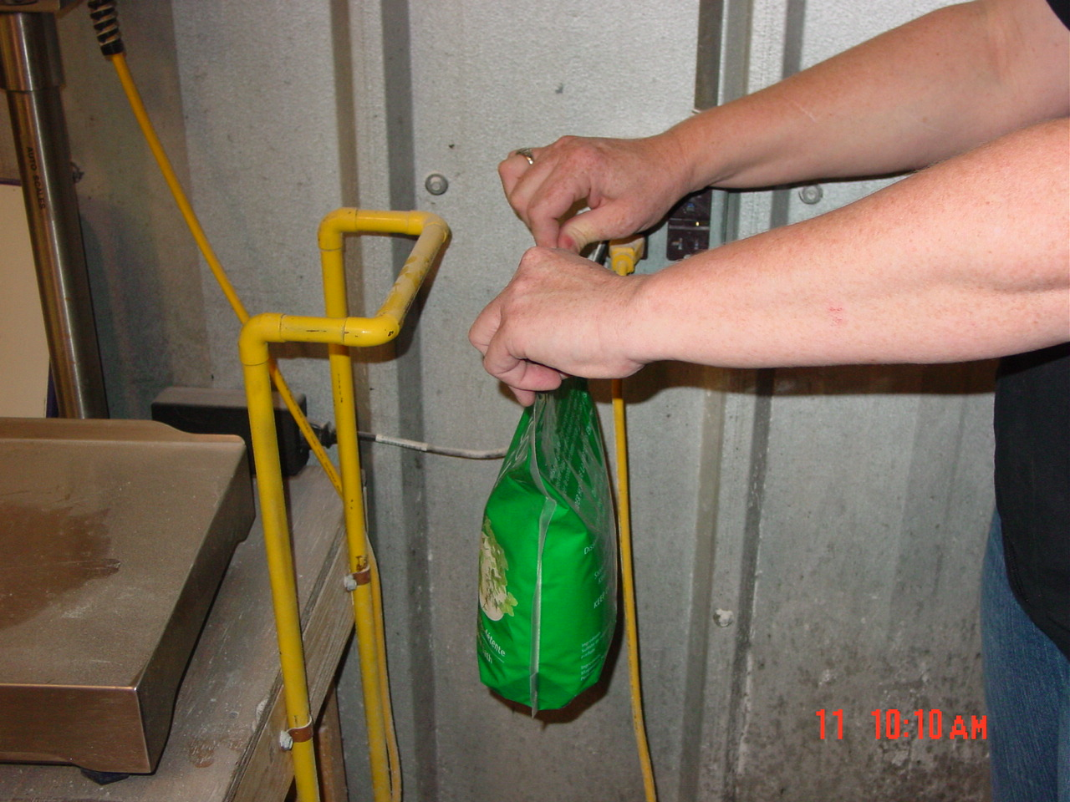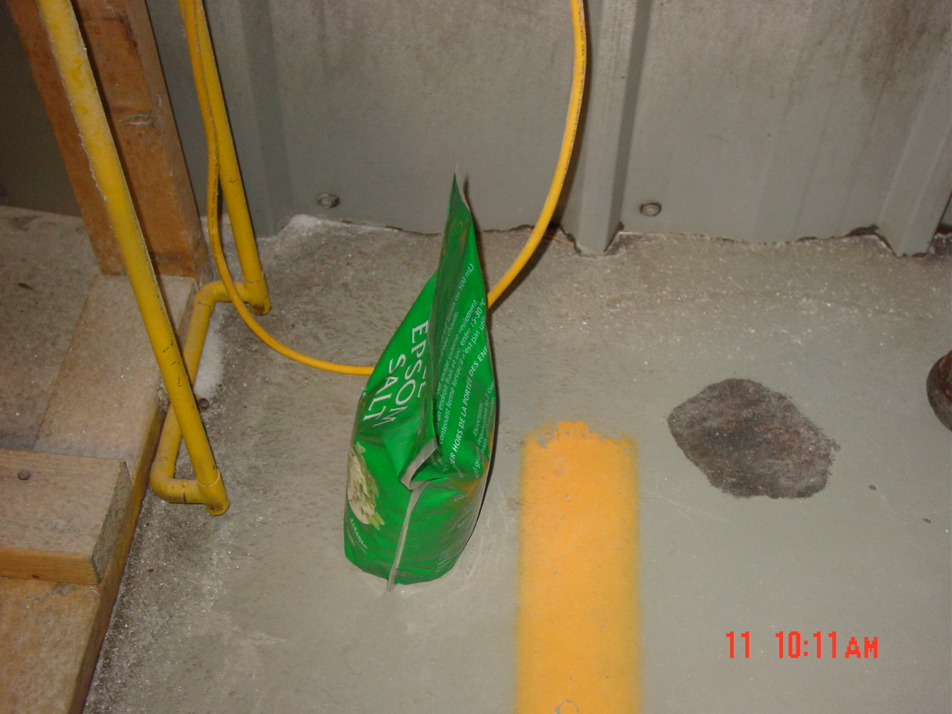

TRAINING DOCUMENTATION

 | EMPLOYEE | TITLE | SIGNATURE | DATE
1
2
3
4
5
6
7
8
9
10
11
12
13
14
15
16
17
18
19
20
21
22
23
24
25
26
27
28
29
30

Revision  Number | Revision  Date | Revision  Author | Revision Description
00 | 06/30/2009 | SL | New Document

